XPath Terminology

Nodes

In XPath, there are seven kinds of nodes: element, attribute, text, namespace, processing-instruction, comment, and document nodes.

XML documents are treated as trees of nodes. The topmost element of the tree is called the root element.

Look at the following XML document:

<?xml version="1.0" encoding="UTF-8"?>  
  
<bookstore>  
  <book>  
    <title lang="en">Harry Potter</title>  
    <author>J K. Rowling</author>  
    <year>2005</year>  
    <price>29.99</price>  
  </book>  
</bookstore>

Example of nodes in the XML document above:

<bookstore> (root element node)  
  
<author>J K. Rowling</author> (element node)  
  
lang="en" (attribute node)

Atomic values

Atomic values are nodes with no children or parent.

Example of atomic values:

J K. Rowling  
  
"en"

Items

Items are atomic values or nodes.

Relationship of Nodes

Parent

Each element and attribute has one parent.

In the following example; the book element is the parent of the title, author, year, and price:

<book>  
  <title>Harry Potter</title>  
  <author>J K. Rowling</author>  
  <year>2005</year>  
  <price>29.99</price>  
</book>

Children

Element nodes may have zero, one or more children.

In the following example; the title, author, year, and price elements are all children of the book element:

<book>  
  <title>Harry Potter</title>  
  <author>J K. Rowling</author>  
  <year>2005</year>  
  <price>29.99</price>  
</book>

Siblings

Nodes that have the same parent.

In the following example; the title, author, year, and price elements are all siblings:

<book>  
  <title>Harry Potter</title>  
  <author>J K. Rowling</author>  
  <year>2005</year>  
  <price>29.99</price>  
</book>

In Selenium automation, if the elements are not found by the general locators like id, class, name, etc. then XPath is used to find an element on the web page .

In this tutorial, we will learn about the xpath and different XPath expression to find the complex or dynamic elements, whose attributes changes dynamically on refresh or any operations.

## What is XPath in Selenium?

**XPath in Selenium** is an XML path used for navigation through the HTML structure of the page. It is a syntax or language for finding any element on a web page using XML path expression. XPath can be used for both HTML and XML documents to find the location of any element on a webpage using HTML DOM structure.

The basic format of XPath in selenium is explained below with screen shot.

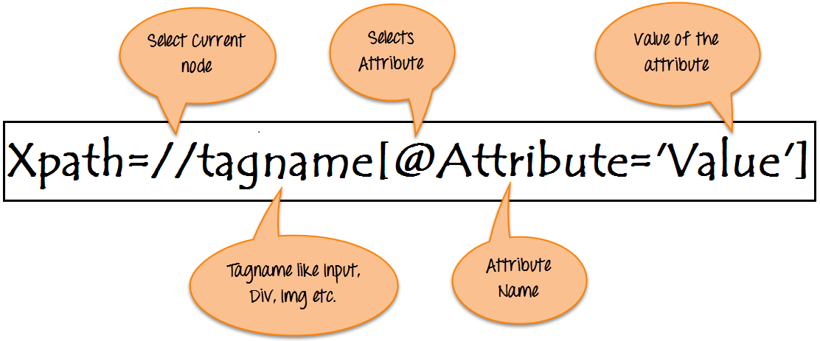

Basic Format of XPath

Learn Java Programming with Beginners Tutorial

**Syntax for XPath selenium:**

XPath contains the path of the element situated at the web page. Standard XPath syntax for creating XPath is.

Xpath=//tagname[@attribute='value']

* **// :** Select current node.
* **Tagname:**Tagname of the particular node.
* **@:** Select attribute.
* **Attribute:** Attribute name of the node.
* **Value:** Value of the attribute.

To find the element on web pages accurately there are different types of locators:

| **XPath Locators** | **Find different elements on web page** |
| --- | --- |
| **ID** | To find the element by ID of the element |
| **Classname** | To find the element by Classname of the element |
| **Name** | To find the element by name of the element |
| **Link text** | To find the element by text of the link |
| **XPath** | XPath required for finding the dynamic element and traverse between various elements of the web page |
| **CSS path** | CSS path also locates elements having no name, class or ID. |

## Types of X-path

There are two types of XPath:

**1) Absolute XPath**

**2) Relative XPath**

### Absolute XPath:

It is the direct way to find the element, but the disadvantage of the absolute XPath is that if there are any changes made in the path of the element then that XPath gets failed.

The key characteristic of XPath is that it begins with the single forward slash(/) ,which means you can select the element from the root node.

Below is the example of an absolute xpath expression of the element shown in the below screen.

NOTE: You can practise the following XPath exercise on this http://demo.guru99.com/test/selenium-xpath.html

Click [here](https://www.guru99.com/faq#faq1) if the video is not accessible

**Absolute XPath:**

/html/body/div[2]/div[1]/div/h4[1]/b/html[1]/body[1]/div[2]/div[1]/div[1]/h4[1]/b[1]

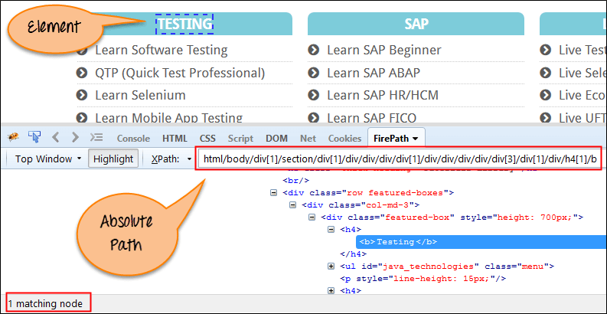

Absolute XPath

### Relative Xpath:

**Relative Xpath** starts from the middle of HTML DOM structure. It starts with double forward slash (//). It can search elements anywhere on the webpage, means no need to write a long xpath and you can start from the middle of HTML DOM structure. Relative Xpath is always preferred as it is not a complete path from the root element.

Below is the example of a relative XPath expression of the same element shown in the below screen. This is the common format used to find element by XPath.